|  |
| --- |
|  |
| Laboratory #2 |
| Active Filters |
|  |
| **Group Members:**  **Steven Le**  **Annie Bui**  **Jon Nguyen**  **Kevin Elevado** |
| **18 February 2013** |

|  |
| --- |
| The purpose of the experiment was to create a variation of active filters from Low Pass to High Pass according to the laboratory specifications. Analysis of roll off frequencies, Ground Loop and bandwidth are all produced to better understand the use of filters. Therefore the behavior of the filters are graphed and recorded to analyze its reliability compared to theoretical results. |

**Pre Lab Exercises**

1. Using any technique available find the transfer function of the first order Low Pass Bessel filter. Show your work for credit.

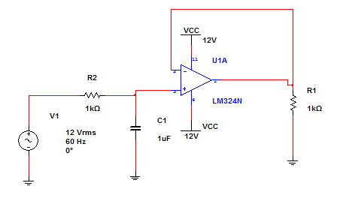

1st Order Low Pass Bessel Filter

Vout = - (Rf/R1) V1

(Rf / R1) = (1k Ω + 1k Ω / 1k Ω) = 2

V1 = 12v

Vout = - (2) 12v

Vout = -24 v

1. Using Multisim Simulate the 1st order Low Pass Bessel Filter. Plot the magnitude (dB) using a VAC input source (set to 1 V) with AC SWEEP from 1 Hz to 100 kHz. The cutoff frequency should be 15 kHz and the value of R = 4.7 kΩ you will have to calculate the value of your capacitor.

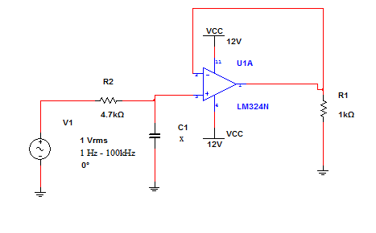

= 2.225 nF

= 10.3174 dB

1. Using Multisim simulate the 1st order High Pass Bessel Filter. The value of R should be 4.7 kΩ, you will have to calculate the value of the capacitor for a cutoff frequency of 15 kHz. Comment on how the cutoff frequency and the slope of the roll off compare to that of Part 2 above.

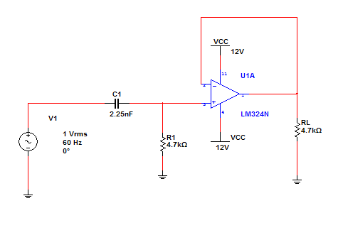

= 0.461 F

= 10.3174 dB

1. Simulate a band pass filter using a single stage amplifier or make one from a cascade of a low pass and a high pass filter. Use a center frequency of 15 kHz and a bandwidth of 25 kHz. Plot the magnitude (dB) and comment on the shape of the plot.

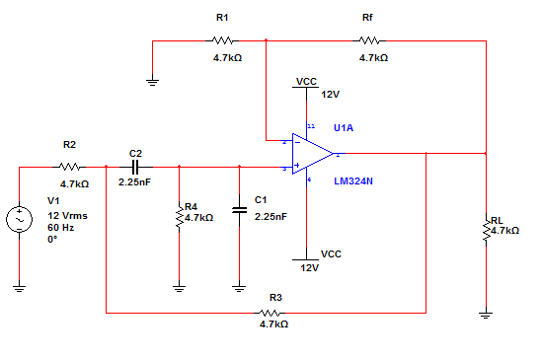

= 10.3174 dB

**Lab Exercises**

1. Construct the low pass filter with unity gain for a cutoff frequency of 15 kHz with a capacitor value of .01 µF.

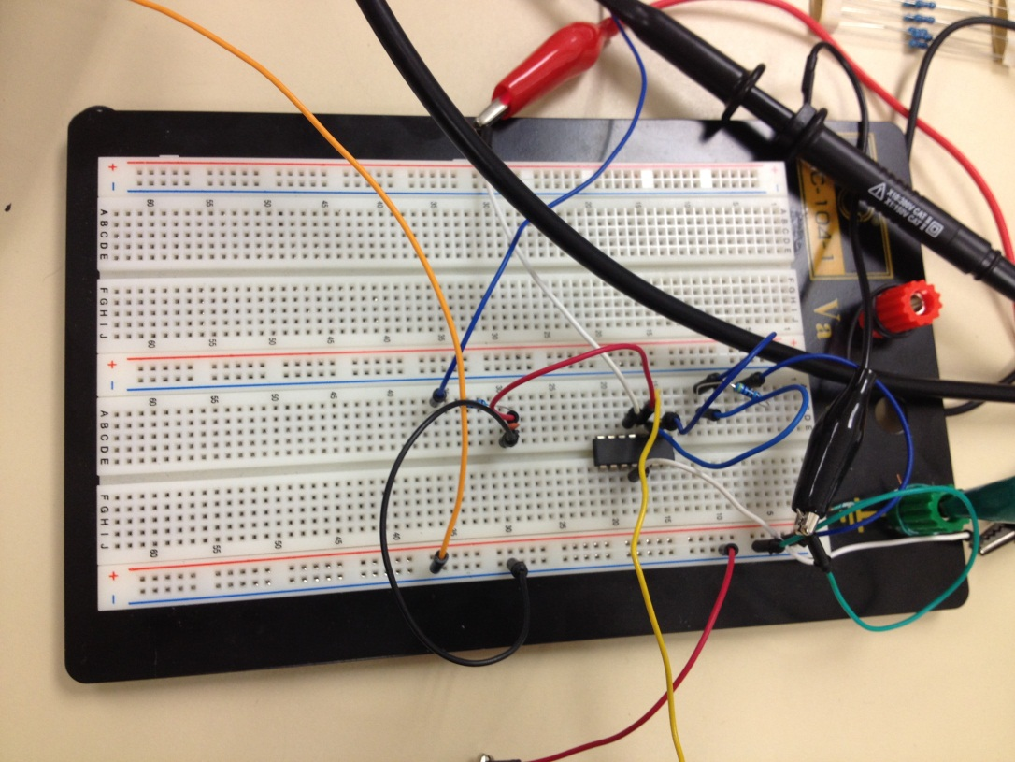

1. Take measurements of the input voltage, output voltage and calculate the gain (in dB) for various frequencies. Record this information on the Data Sheet.

|  |  |  |  |
| --- | --- | --- | --- |
| Frequency | Input Voltage | Output Voltage | dB= 20 log(Gain) |
| 10 Hz | 68.8v | 19.6v | 10.9066 dB |
| 100 Hz | 20.2v | 20.4v | -0.0855 dB |
| 1 kHz | 19.8 v | 19.4 v | 0.1772 dB |
| 5 kHz | 21.8 v | 12.6 v | 4.7617 dB |
| 10 kHz | 20.2 v | 7.20 v | 8.9603 dB |
| 15 kHz | 19.6 v | 13.5 v | 3.2384 dB |
| 20 kHz | 19.6 b | 4.0 v | 13.8039 dB |
| 50 kHz | 19.5 v | 1.80 v | 20.6952 dB |
| 100 kHz | 19.6 v | 1.10 v |  |

Construct the high pass filter with unity gain using the same component values from Part 1.

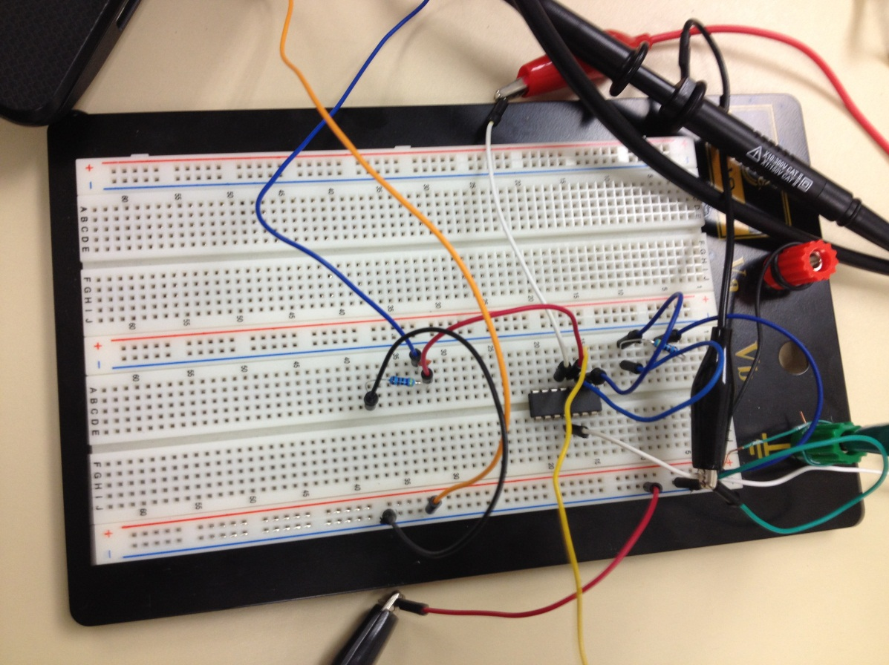

1. Take measurements of the input voltage, output voltage and calculate the gain (in dB) for various frequencies. Record this information on the Data Sheet.

|  |  |  |  |
| --- | --- | --- | --- |
| Frequency | Input Voltage | Output Voltage | dB= 20 log(Gain) |
| 10 Hz | 5 v | 28 mV | 65.0362 dB |
| 100 Hz | 20.6 v | 484 mV | 52.5804 dB |
| 1 kHz | 19.6 v | 4.45 v | 12.8779 dB |
| 5 kHz | 74.6 v | 14.2 v | 14.4090 dB |
| 10 kHz | 74.2 v | 17.2 v | 12.6975 dB |
| 15 kHz | 74.2 v | 18.4 v | 12.1117 dB |
| 20 kHz | 74.4 v | 15.8 v | 13.4583 dB |
| 50 kHz | 74.2 v | 5.88 v | 22.0205 dB |
| 100 kHz | 74 v | 3.60 v | 26.2585 dB |

1. Construct the band pass filter (or of a cascade of a low pass and a high pass) with a center frequency of 15 kHz and a bandwidth of 25 kHz. Use values from the Pre Lab for components or items that are comparably close.

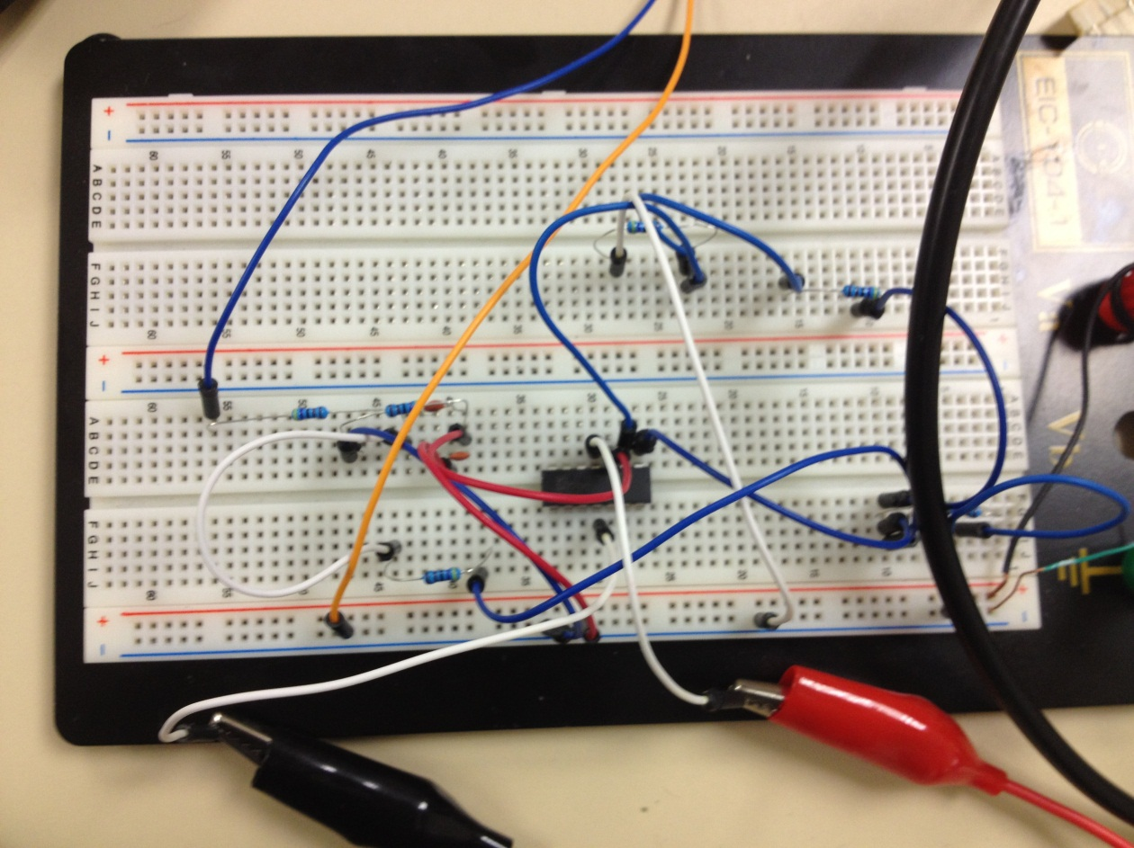

1. Take measurements of the input voltage, output voltage and calculate the gain (in dB) for various frequencies. Record this information on the Data Sheet.

|  |  |  |  |
| --- | --- | --- | --- |
| Frequency | Input Voltage | Output Voltage | dB= 20 log(Gain) |
| 10 Hz | 20.2 v | 52 mV | 71.7869 dB |
| 100 Hz | 74.6 v | 624 mV | 61.5510 dB |
| 1 kHz | 74.8 v | 6.08 v | 21.7999 dB |
| 5 kHz | 74.2 v | 15.7 v | 13.4900 dB |
| 10 kHz | 74.6 v | 12.2 v | 15.7257 dB |
| 15 kHz | 74.4 v | 9.00 v | 18.3466 dB |
| 20 kHz | 74.6 v | 7.40 v | 20.0701 dB |
| 50 kHz | 73.8 v | 3.36 v | 26.8343 dB |
| 100 kHz | 74.2 v | 1.72 v | 32.6975 dB |

**Post Lab Questions**

1. Determine the cutoff frequency of the First Order LP Filter and compare to the theoretical value. Draw a graph and note the cutoff frequency of the measured data.

The cutoff frequency of the First Order LP Filter is 15 kHz compared to 7.153 kHz which is the theoretical value.

1. What is the gain of the First Order LP Filter in the pass band? How does this compare to the theoretical value? What is the roll off rate of the filter in the stop band?

The gain of the First Order LP Filter in the pass band is 10 – 25 dB

This compares to the theoretical value of 2 dB because both are closely converging to each other which suggests that the measured value is correct. The roll off rate of the filter in the stop band is 8 dB. The roll off rate determined the steepness of the frequencies which was reasonable in accordance to the circuit made.

1. Determine the cutoff frequency of the First Order HP Filter and compare to the theoretical value. Draw a graph and note the cut off frequency of the measured data.

The cutoff frequency of the First Order HP Filter was recorded as 15 kHz while the theoretical value was 7.534 kHz. Compared to the theoretical value, the actual cutoff frequency was slightly off the theoretical value.

1. What is the gain of the First Order HP Filter in the pass band? How does this compare to the theoretical value? What is the roll off rate of the filter in the stop band?

The gain of the First Order HP Filter is 12 dB in the pass band. This value compares to the theoretical value because it is similar which proves that the recorded data is reliable.

1. Draw a graph of the Band Pass Filter and show the two cutoff frequencies. Comment on how they compare to the theoretical frequencies and the bandwidth of the filter.

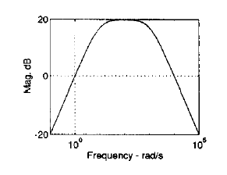

1. Look up the definition of a Ground Loop and explain on how it can effect measurements made on the filters input signal and output signal. Explain how these might be able to be avoided, or minimized. Do you feel that there could be any Ground Loop problems in the circuits that were constructed in the lab?

The Ground Loop to refers to a current, almost always unwanted, in a conductor connecting two points that are supposed to be at the same potential, often ground, but are actually at different potentials. This can impact the measurements, straying from the true values of the input and output signals. It could be avoided by minimizing the amount of grounds that are necessary for the cables, but it was not done so during this lab.

Conclusion

The purpose of this lab is to understand the differences between low pass, high pass, and band pass filter with their correlations between frequencies and corresponding output voltages. Based on the data calculations, on low pass filters, when increasing frequency, the voltage amplitude decreases, resulting in decreased voltage output. High pass filters increase voltage amplitude when increasing frequency. Band pass filters when approaching selected range based on op-amp specifications, will increase voltage amplitude to its peak, then decrease in a shape of a bell curve waveform.